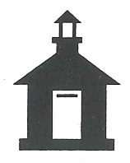
Raisinville Township
96 Ida-Maybee Road
Monroe, MI 48161

Township Board Meeting  (1st Tuesday)* | Planning Commission  (3rd Monday) | Zoning Board of Appeals  (Last Monday if needed)
2026 | 2026 | 2026
July 7 | July 20 | July 27
*August 11 (2nd Tuesday) | August 17 | August 31
September 1 | September 21 | September 28
October 6 | October 19 | October 26
*November 10(2nd Tuesday) | November 16 | November 30
December 1 | December 21 | December 28
2027 | 2027 | 2027
January 5 | January 18 | January 25
February 2 | February 15 | February 22
March 2 | March 15 | March 29
April 6 | April 19 | April 26
May 3 | May 17 | May 31
June 1 | June 21 | June 28
The Raisinville Township Boards will meet on the
following dates for the 2026-2027 year.
All meetings will begin at 7:00 pm and will be held at the
Township Hall, 96 Ida-Maybee Road, Monroe, MI 48161.

*Township Board Meeting Dates changes are due
to the Primary & General Elections*

